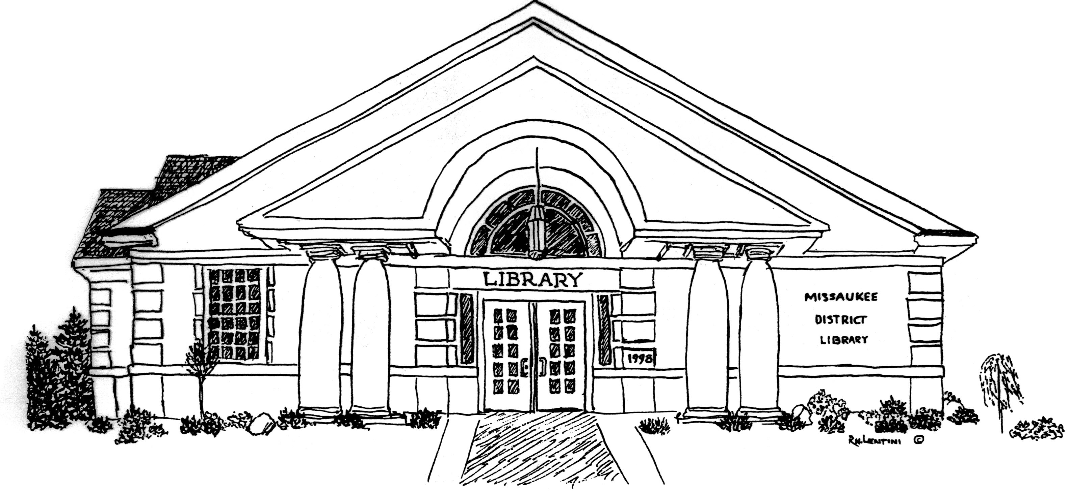
Ardis Missaukee District Library
210 South Canal Street, PO Box 340
Lake City, Michigan 49651
phone: 231-839-2166

Reopening Plan

The Missaukee District Library is pleased to share their Reopening Plan.

Beginning June 3rd Reopening Plan Phase 1 has begun at the library. We have invited limited STAFF ONLY to return to organize the collection, clean all surfaces, prepare building for social distancing guidelines including signage, and collect personal protective equipment for the staff.

If all goes as expected with the Executive Orders, our Reopening will happen Monday, June 8th from 9:00 a.m. – 6:00 p.m. The library will be busy with patrons wanting their first library books in 2 ½ months. We will be able to house approximately 30 patrons following social distancing rules. Per Executive Order 2020-92 “any individual able to medically tolerate a face covering must wear a covering over his or her nose and mouth—such as a homemade mask, scarf, bandana, or handkerchief—when in any enclosed public space.”

We will offering curbside service. Patrons may request a book over the phone, then they will be able to make arrangements for a staff member will bring it to their car. Because more staff is needed for this service, the library will be accepting donations to help offset these costs.

Six of our 12 Computers will be available to patrons. Disposable disinfecting cloths will be supplied to sanitize computers between uses. Cleaning of handles, hard surfaces, and bathrooms will occur throughout the day following CDC guidelines.

Returned paperback books will be held for 24 hours, and milar-covered books will be held for 24 hours (with sanitizing wiping) before reshelving. We will accept book donations using the 72 hour quarantine requirement.

Unfortunately the MeLCat service, which borrows books from other libraries in Michigan, will be suspended for a little while longer.

As more positive Covid-19 information becomes available, Phase 3 and 4 will expand the number of patrons able to use the library at one time. All appropriate safeguards will continue to be used.

The Missaukee District Library Board and Staff are very excited to be ready to serve our patrons again. If something changes before our Reopening on Monday, June 8th, then please check out our website www.missaukeelibrary.org for our revised plans.

